**DAILY ONLINE ACTIVITIES SUMMARY**

|  |  |  |  |  |  |  |  |  |
| --- | --- | --- | --- | --- | --- | --- | --- | --- |
| **Date:** | **21/05/2020** | | | | | **Name:** | **NAIPUNYA VINOD NAIK** | |
| **Sem & Sec** | **IV SEM & A SECTION** | | | | | **USN:** | **4AL18CS050** | |
| **Online Test Summary** | | | | | | | | |
| **Subject** | | **MICROCONTROLLER AND EMBEDDED SYSTEMS** | | | | | | |
| **Max. Marks** | | **30** | | **Score** | | | **24** | |
| **Certification Course Summary** | | | | | | | | |
| **Course** | **INTRODUCTION TO HADOOP** | | | | | | | |
| **Certificate Provider** | | | **GREAT LEARNING**  **ACADEMY** | | **Duration** | | | **5.5 HRS** |
| **Coding Challenges** | | | | | | | | |
| **Problem Statement:** 1)[Write C Program to create Singly Liked List with n elements and reverse the elements using C.](https://github.com/orgs/alvas-education-foundation/teams/2nd-year/discussions/71)  Top of Form  Bottom of Form   |  | | --- | | Hint: Create the SLL, and then Reverse the Link in SLL until Head becomes NULL. Each Time Reversing the Link, Head must be moved to next immediate node. |   **2)** Write a C program to implement SRTF process scheduling.  Input: A set of processes with their burst time and arrival time Output: The processes scheduled based on the arrival time and a smaller burst time.    Top of Form  Bottom of Form    Top of Form  Bottom of Form   |  |  | | --- | --- | |  | | |  |     Top of Form  Bottom of Form    Top of Form  Bottom of Form    [Write a C program to implement SRTF process scheduling.](https://github.com/orgs/alvas-education-foundation/teams/2nd-year/discussions/73)  [@HARSHITHA-GM](https://github.com/HARSHITHA-GM)  [HARSHITHA-GM](https://github.com/HARSHITHA-GM)  [7 hours ago](https://github.com/orgs/alvas-education-foundation/teams/2nd-year/discussions/73)  Top of Form  Bottom of Form   |  | | --- | | Write a C program to implement SRTF process scheduling. Input: A set of processes with their burst time and arrival time Output: The processes scheduled based on the arrival time and a smaller burst time. |   Top of Form  Bottom of Form    Top of Form  Bottom of Form    [Write a simple applet java program to check whether the given number is armstrong number or not.](https://github.com/orgs/alvas-education-foundation/teams/2nd-year/discussions/74)  [@shilpahassan](https://github.com/shilpahassan)  [shilpahassan](https://github.com/shilpahassan)  [6 hours ago](https://github.com/orgs/alvas-education-foundation/teams/2nd-year/discussions/74)  Top of Form  Bottom of Form   |  |  | | --- | --- | | Input: GUI Should contain a Label (name it as Enter a Number), a Textfield (To read the number), and a button. Output: Onlick of the button it should display In Label With Color RED and font Size 25pt as ### Armstrong, if not then Not a Armstrong.  Description Armstrong Number :A positive number is called armstrong number if it is equal to the sum of cubes of its digits for example 0, 1, 153, 370, 371, 407 etc.  Let's try to understand why 153 is an Armstrong number. 153 = (111)+(555)+(333) where: (111)=1 (555)=125 (333)=27 So: 1+125+27=153 | | | [@naipunya-naik](https://github.com/naipunya-naik)  Reply… |     Top of Form  Bottom of Form    Top of Form  Bottom of Form    [Write a C program to implement SRTF process scheduling.](https://github.com/orgs/alvas-education-foundation/teams/2nd-year/discussions/73)  [@HARSHITHA-GM](https://github.com/HARSHITHA-GM)  [HARSHITHA-GM](https://github.com/HARSHITHA-GM)  [7 hours ago](https://github.com/orgs/alvas-education-foundation/teams/2nd-year/discussions/73)  Top of Form  Bottom of Form   |  | | --- | | Write a C program to implement SRTF process scheduling. Input: A set of processes with their burst time and arrival time Output: The processes scheduled based on the arrival time and a smaller burst time. | | | | | | | | | |
| **Status: EXECUTED** | | | | | | | | |
| **Uploaded the report in Github** | | | | | **YES** | | | |
| **If yes Repository name** | | | | | <https://github.com/naipunya-naik/lockdown-coding/blob/master/reverse%20linked%20list.c>  <https://github.com/naipunya-naik/lockdown-coding/blob/master/SRTF.c> | | | |
| **Uploaded the report in slack** | | | | | **YES** | | | |

Online Test Details: (Attach the snapshot and briefly write the report for the same)

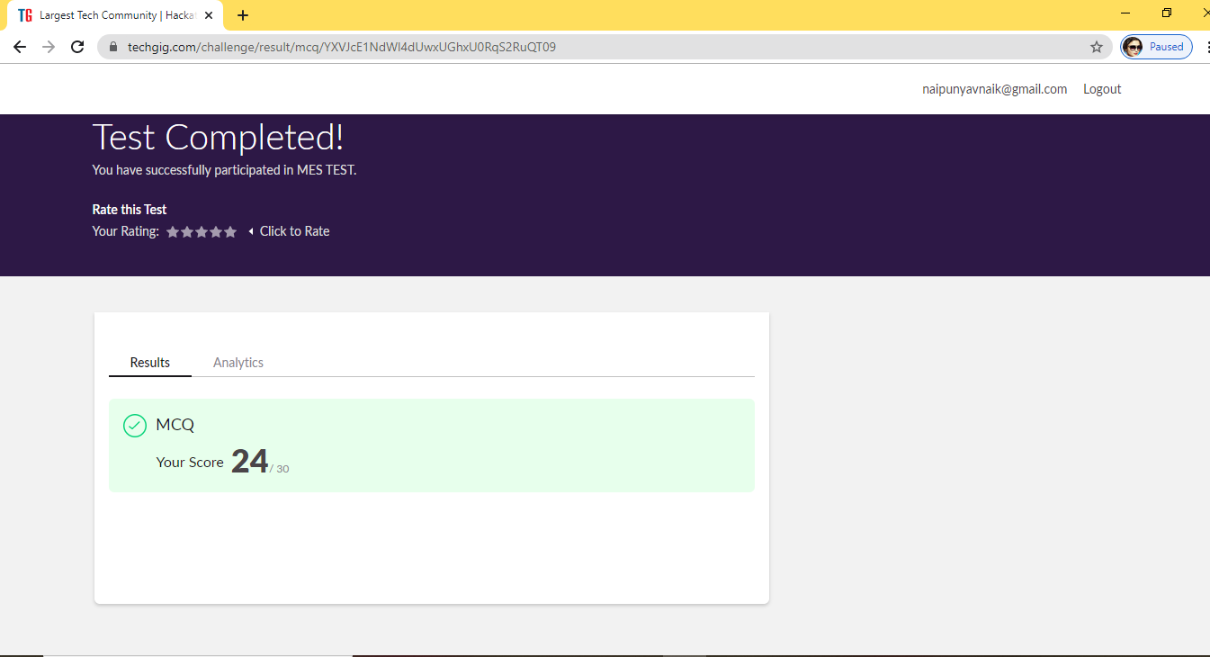

* THE MICROCONTROLLER AND EMBEDDED SYSTEMS

1ST I.A ONLINE TEST WAS CONDUCTED ON 21 MAY 2020.

* SUBJECT NAME: MICROCONTROLLER AND EMBEDDED SYSTEMS
* SYLLABUS:- MODULE 1
* START TIME:-10 AM
* END TIME:- 10.30 AM
* DURATION:-30 MIN
* NO. OF QUESTIONS: 30
* EACH QUESTION CARRIED 1 MARK.

Certification Course Details: (Attach the snapshot and briefly write the report for the same)

CERTIFICATION COURSE NAME:- INTRODUCTION TO HADOOP

THIS THE CERTIFICATE OF COMPLETION OF INTRODUCTION TO HADOOP ONLINE CERTIFICATION COURSE.

TOPICS COVERED THROUGHOUT THE COURSE:-

* Intro to big data
* What is ETL
* Intro to Hadoop
* Distributed Computing
* Hadoop Architecture
* How do we Store a File in HDFS
* Intro To Oozie and HDFS Processing
* Hadoop Cluster Hands on
* Hadoop Ecosystem
* Map Reduce
* Map Reduce Example
* Map Reduce Practice Example
* Map Reduce Programmatic Comparison with Java
* Map Reduce Hands on - Word Count
* Map Reduce Word Count Code

Coding Challenges Details: (Attach the snapshot and briefly write the report for the same)

PROBLEM STATEMENT 1:-

1)[Write C Program to create Singly Liked List with n elements and reverse the elements using C.](https://github.com/orgs/alvas-education-foundation/teams/2nd-year/discussions/71)

Top of Form

Bottom of Form

|  |
| --- |
| Hint: Create the SLL, and then Reverse the Link in SLL until Head becomes NULL. Each Time Reversing the Link, Head must be moved to next immediate node. |

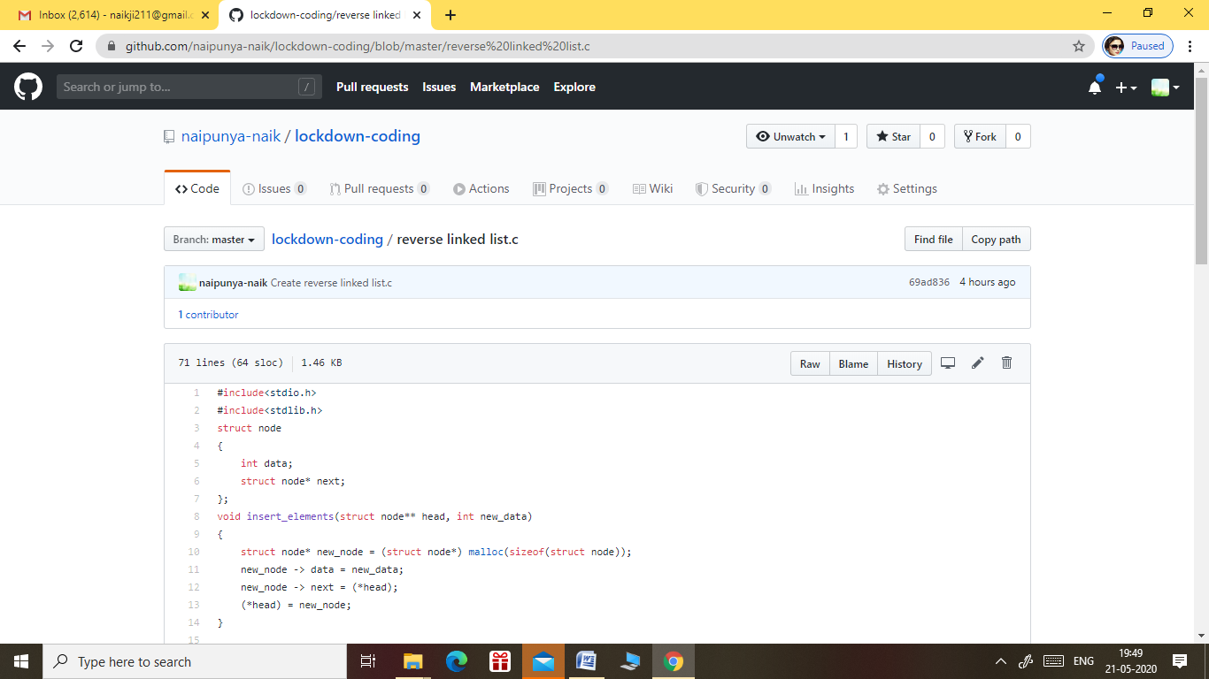

GITHUB REPOSITORY LINK:-

<https://github.com/naipunya-naik/lockdown-coding/blob/master/reverse%20linked%20list.c>

PROBLEM STATEMENT **2:-** Write a C program to implement SRTF process scheduling.  
Input: A set of processes with their burst time and arrival time   
Output: The processes scheduled based on the arrival time and a smaller burst time.

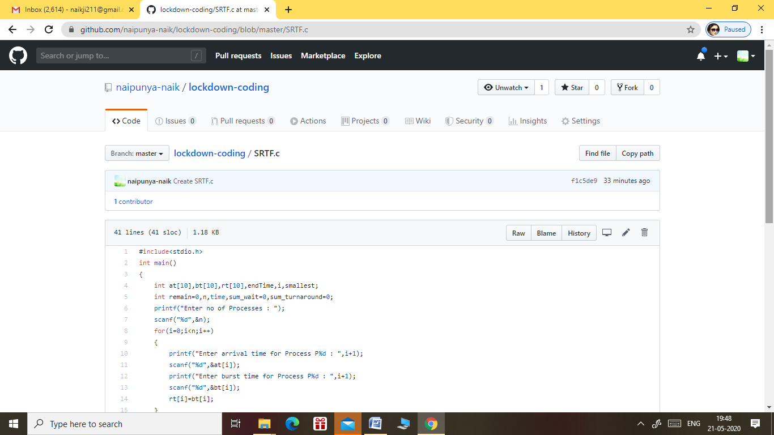

GITHUB REPOSITORY LINK:-

<https://github.com/naipunya-naik/lockdown-coding/blob/master/SRTF.c>